**Armstrong Youth Orchestra - ARMSTRONG YOUTH ORCHESTRA PROGRAM**

**AYO Cello - Required excerpts F22**

**All audition information is available on our AYO website: ayosavannah.org**

**Your audition will include:**

1. **Prepared solo of your choice**
2. **Scales as listed on the AYO website**
3. **Required excerpts.**

**Page 1/2**

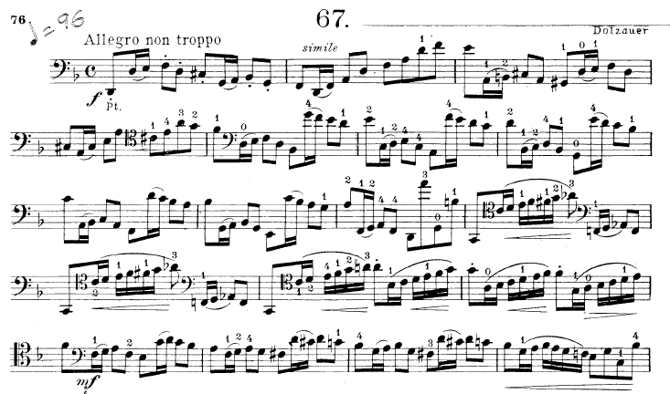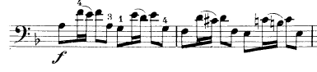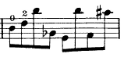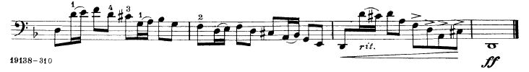

**Armstrong Youth Orchestra**

**Cello Audition Etude/Excerpts F16**

**Page 2/2**

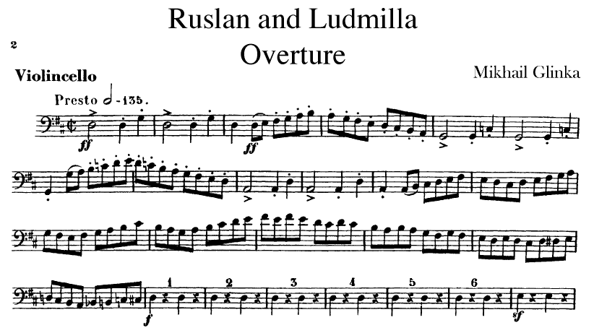

**Offenbach - Orpheus in the Underworld**

