Repertory Youth Orchestra (RYO) – ARMSTRONG YOUTH ORCHESTRA
Bass Audition Etude
F-22

Quarter Note = 92

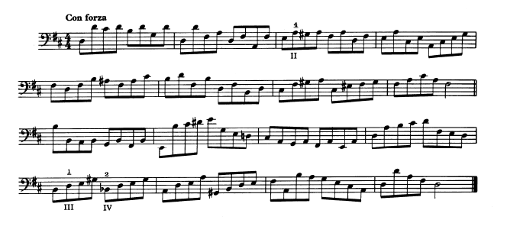

Russian Sailor’s Dance
Quarter Note = 72

