Armstrong Youth Orchestra Program
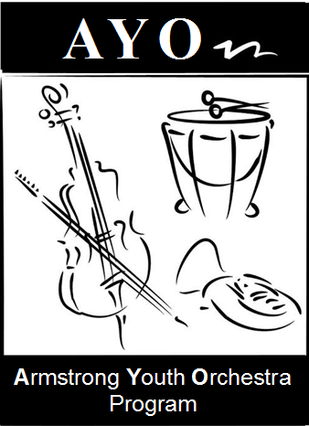 Program Ad Sign-up Sheet

Dear Parents - Help support your youth orchestra!
We will be selling program advertisements for our Fall Concert on November 24th.
Our Concert programs are printed on 11x 17 in Black/White. All we will need from you is for you to email us your business ad or “Parent Congratulations” message. We can accept artwork in a JPEG or PDF file. Please select the size of your ad below and bring your check made out to GSU to rehearsal.

All ads need to be emailed to us by November 12th.
Email: ayosavannah2004@gmail.com

□ Back cover (8.5 x 11) $250
□ One whole inside page (8.5 x 11) $200
□ 1/2 page $120
□ 1/3 page $85
□ 1/4 of a page ((4.25 x 2.75) $65
□ Business card (3.5 x2) $35

Name:

Phone Email:
Ck#: Cash:

Please make checks payable to: GSU

